# **Use Case Diagram of Overall System.**

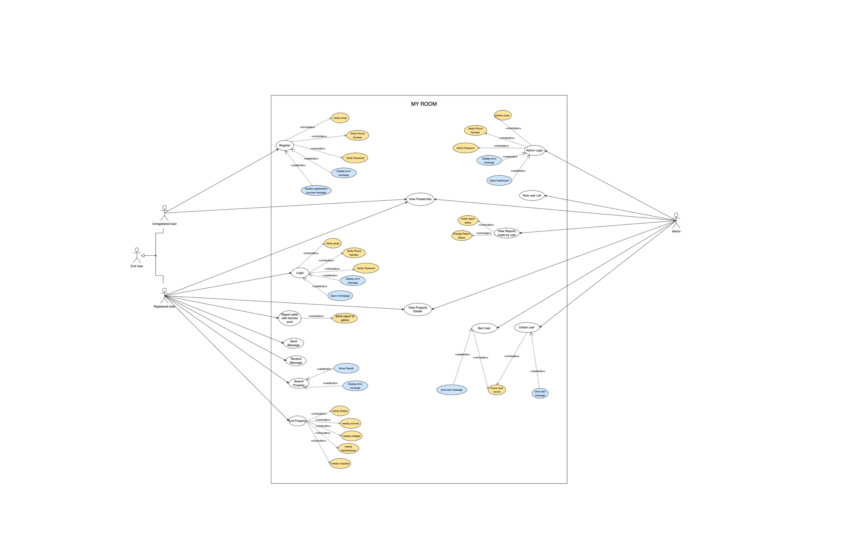

Figure 1: Use case Diagram of overall system